

(A**n Online Test Application.**)

***(Source Code)***

**Online Quiz….**

# Version History:



|  |  |  |
| --- | --- | --- |
| **1.** | **Author Name** | **DUDEKULA KALAM BASHA** |
| **2.** | **Purpose** | Source Code. |
| **3.** | **Date** | 09 April 2022 |
| **4.** | **Version** | 1.0 |
| **5.** | **Contact** | *Kalambasha9701@gmail.com* |

**Content**

1. Project Link 3
2. Folder Structure 4
3. Project Files 5

# Project Link.

|  |  |
| --- | --- |
| **Repository Name.** | OnlineTestApplication. |
| **GitHub Link.** | https://github.com/kalam9701/Phase-4-Final-Assessment.git |

* 1. Folder Structure.

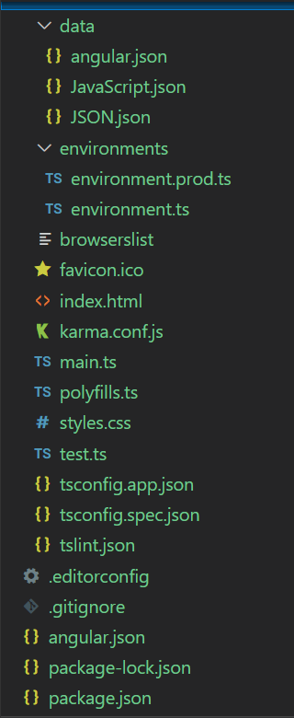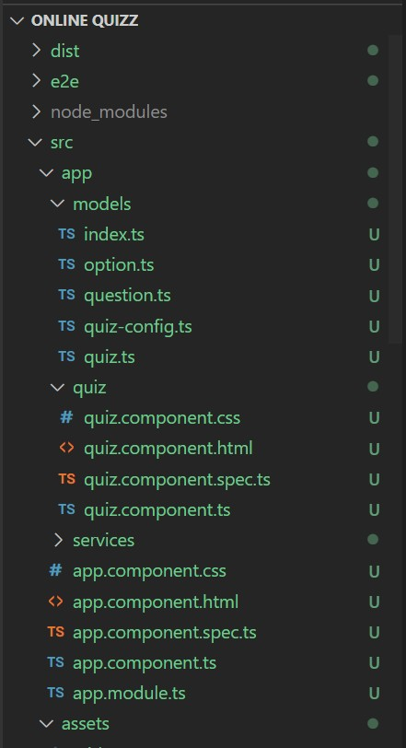

* 1. Project Files.

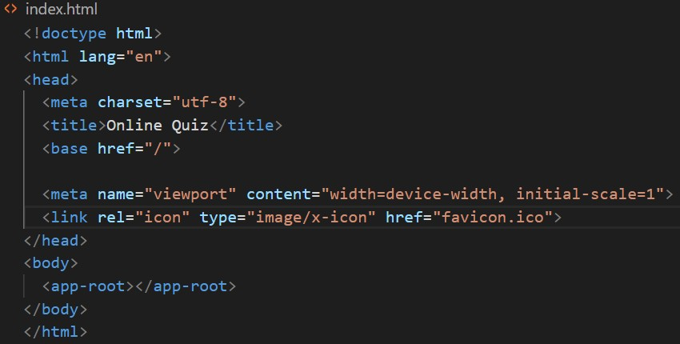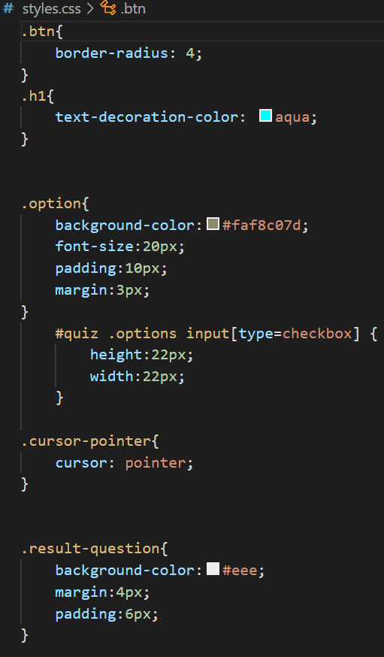

* ***Style.css***

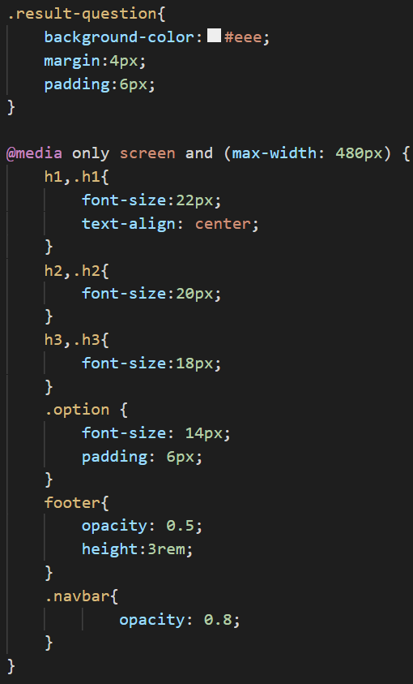

* ***App.component.html***

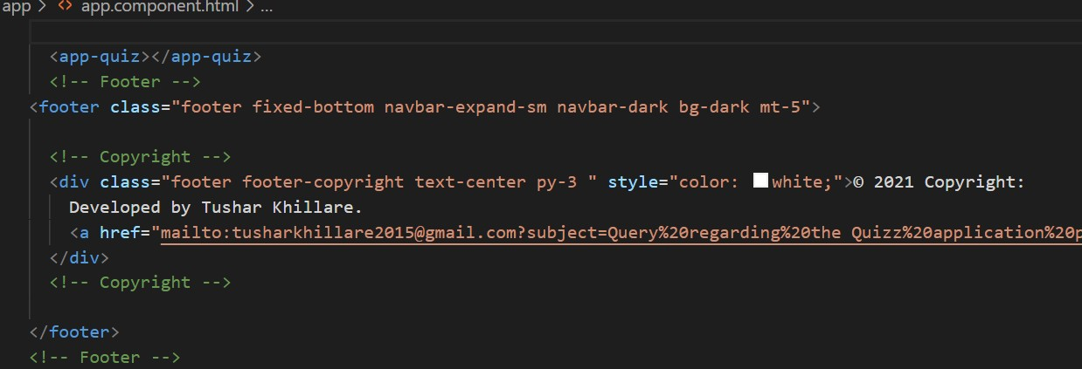

* ***Quiz.service.ts***

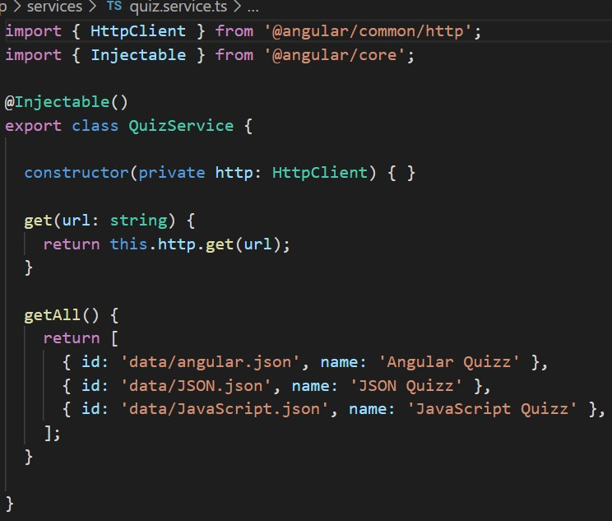

* ***App.component.ts***

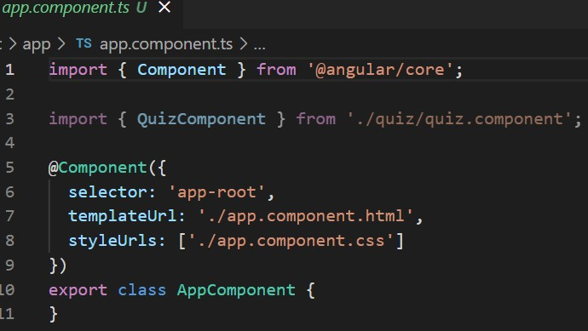

[**Note**: Rest of files are upload on the GitHub Link given above.]

**Thank You……………**